**EXPERIMENT – 10**

Create a Cloning of a VM and Test it by loading the Previous Version/Cloned VM using virtual box.

Aim:

To create a clone of a Virtual Machine in VirtualBox and test it by loading the cloned VM independently.

Procedure:

1. Open Oracle VirtualBox on your host system.

2. Select the virtual machine (VM) you want to clone.

3. Make sure the VM is powered off before cloning.

4. Go to Machine → Clone from the menu bar.

5. The Clone Virtual Machine wizard opens → Click Next.

6. Enter a name for the cloned VM and choose a location to store it.

7. Select the type of clone: o Full Clone – creates an independent copy of the VM. o Linked Clone – shares disk with the original VM, saving space.

8. Click Clone → VirtualBox will create the cloned VM.

9. Once the cloning process is complete, select the cloned VM and start it.

10. Verify that the cloned VM loads successfully and works independently from the original VM.

Output:

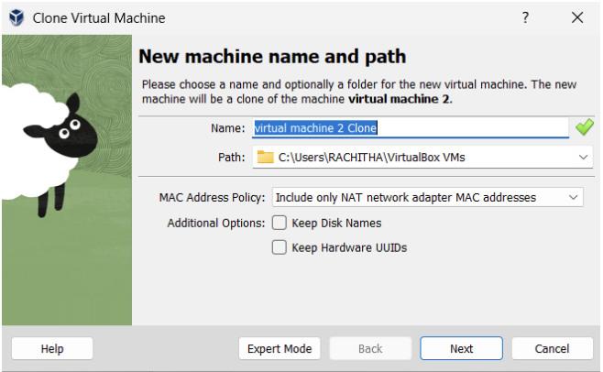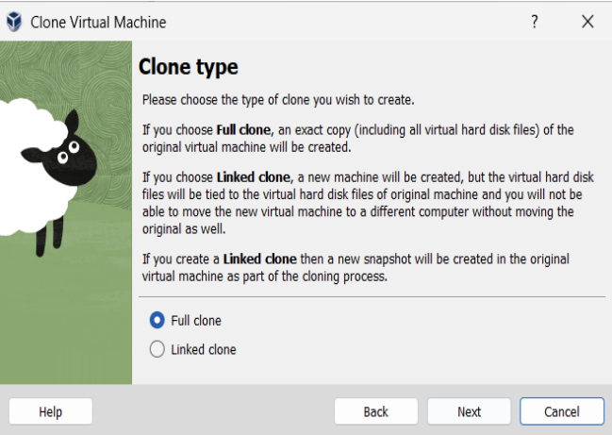

Result:

The VM was successfully cloned in VirtualBox. The cloned VM started and functioned correctly, demonstrating independent operation and the cloning feature for testing or backup purposes.